**Second Round of Analogues**

Optimization based on bioavailability factors

Based on Remdesivir

Analogue 3

Added PEG chain to increase retention

O=C(OCOCCOCCOCCOCCOCCOCCO)[C@@H](NP(Oc1ccccc1)(OC[C@H]2O[C@@](c3ccc4n3ncnc4N)([C@@H](O)[C@H]2O)C#N)=O)C

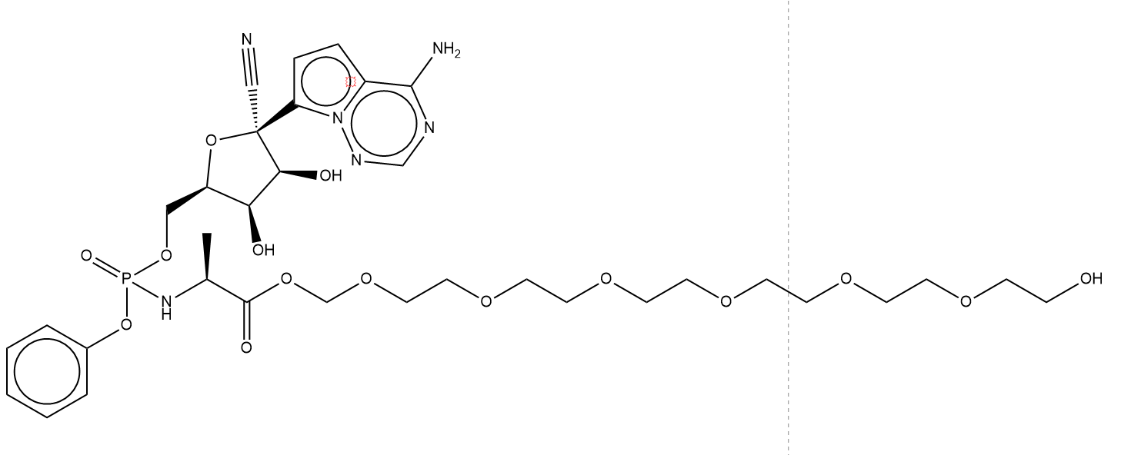

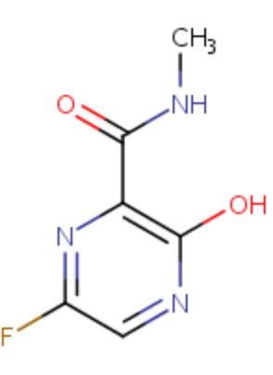Based on Favipiravir

Analogue 2

O=C(c1c(O)ncc(F)n1)NC